**Using the software**

**Before using this software make sure that you have backed up all images. This program will move/rename/override images. By only running this on copies of the images you will have backups in case something goes wrong.**

The first thing that you should notice is that there are three separate steps to this software. The first step has three questions:

* 1. “Where are the images currently?” – This is where the images with their old names are currently stored. The application will convert all of the images located in this folder.
  2. “Where should the images be after conversion?” – Once the application is finished converting the images it will move them into the folder that you select here (it can be same folder from the first question).
  3. “Where is the CSV file?” – For this question you will select the CSV file containing the class information.

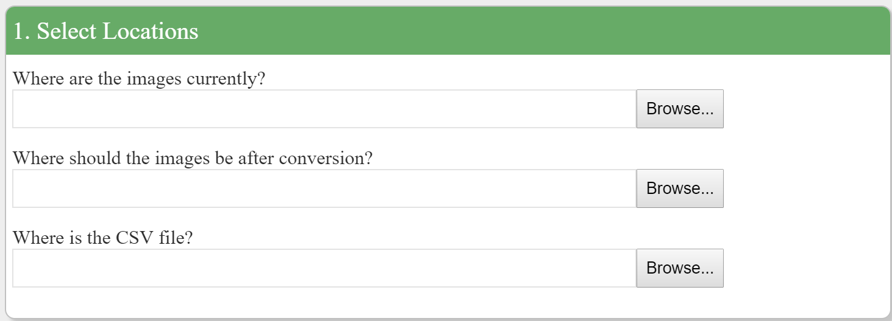

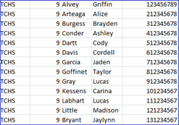The second step is where you specify what the columns in the CSV file are. To add a column click on the plus icon. You can name each column here to make the next step easier. For example, if your CSV file looks like this:

Then you would want to set up your columns in the application like this:

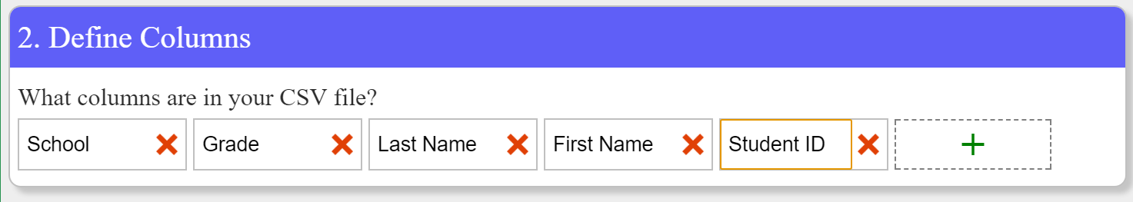

The third step is the most complicated. In this step you need to specify what the current image format is and what the new format should be. In this section there are dropdowns and there are free text fields. The dropdowns contain all of the columns that you defined in part two of the application. To add more fields you can click the small plus icon at the end of each row.

For example: if your image was originally named “Garcia, Jaden.jpg” then you would set up the current format like this:

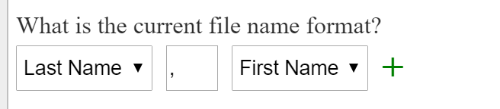

It is difficult to tell in this screen shot but the middle field here contains a comma and a space (just like the images original name format).

Another example “Garcia, Jaden - TCHS.jpg” then you would set it up this way:

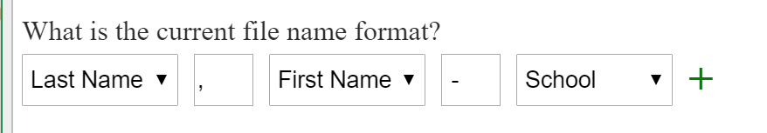

The second question works the same way as the first. Let’s say that I want to convert the images to the student ID.

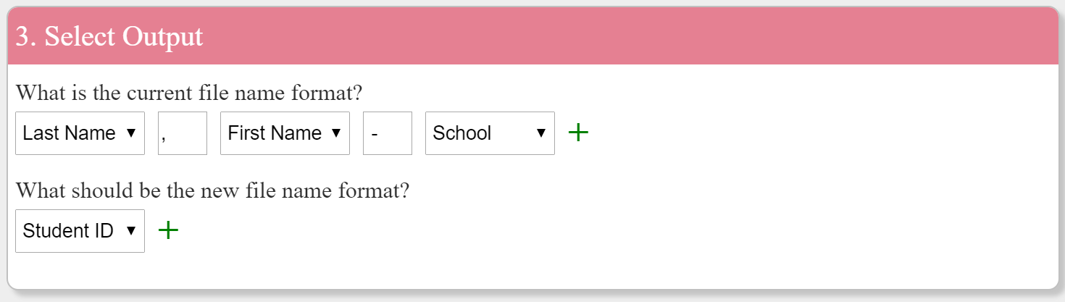

Once everything is set up click the Convert! button.



If the conversion was successful then you should see a message like this:

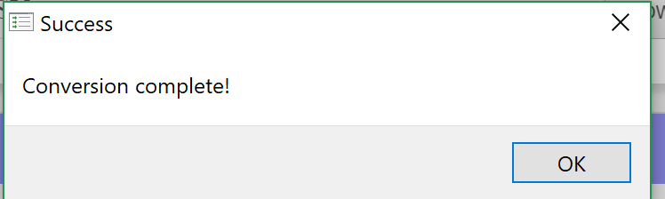

If there were any issues then you will see the messages in a different popup.

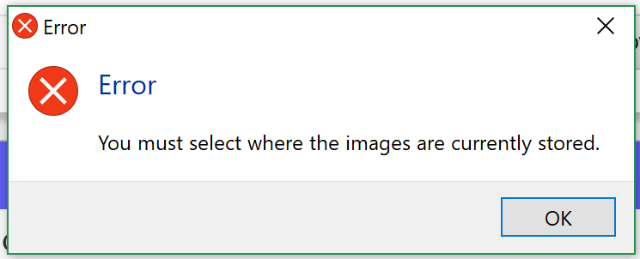

Lastly check to make sure that the images have all been converted. Any images that weren’t converted couldn’t be found in the spreadsheet (this would most likely be due to a typo).